NOTICE is hereby given that the 153rd Annual General Meeting of the Bristol Law Society (“the Society”) will be held on Tuesday 21st November 2023 at 5.45pm for registration with business to commence at 6.00pm. This AGM will be held in person with a hybrid facility at the Office of DAC Beachcroft, Portwall Place, Portwall Lane, Bristol, BS1 6NA. Please email info@bristollawsociety.com if you will be attending the AGM in-person or if you require online joining details.

This AGM will be for the purpose of considering the following business:

- Receiving Apologies

- Minutes of the 152nd Annual General Meeting held on 16th November 2022

- Proposed Amendments to the Articles of Association of the Bristol Law Society

- Report of the Council (including Co- Presidents’ and Honorary Secretary’s Reports)

- Honorary Treasurer’s Report

- Appointment of Milsted Langdon LLP as the Society’s Accountants

- The election of: President
Senior Vice President
Junior Vice President
Honorary Treasurer
Honorary Secretary
Ordinary Members of Council

- The Investiture of the President of the Society

- Any other Business

By Order of the Council
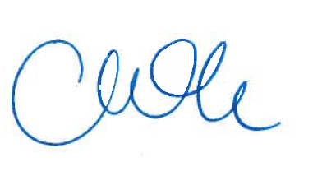
Coralie McKeivor Dated: 27 October 2023
Hon Secretary

Registered Office: C/o Milsted Langdon LLP, Freshford House, Redcliffe Way, Bristol, BS1 6NL

A member entitled to attend the meeting is entitled to appoint a Proxy to attend in their place. A proxy need not be a member of the Society.

Note: The Society’s Articles of Association require that nominations for election should be sent to the Honorary Secretary at officers@bristollawsociety.com, not less than 7 days before the Annual General Meeting and shall be signed by two or more members of the Society.

SPECIAL RESOLUTION AMENDING ARTICLES OF ASSOCIATION
THAT the proposed amendments to the Articles of Association of Bristol Law Society as set out in the draft Articles of Association attached to this resolution be adopted as the Articles of Association of the Company in substitution for, and for the exclusion of, the Company’s existing Articles of Association.

