Judicial Reverse Mentoring Pen Point: Information for Legal Professionals

Becoming a Judicial Reverse Mentor
The Judiciary have developed a scheme to enable lawyers to mentor a salaried judge in an arrangement known as “Reverse Mentoring”. The scheme provides for Judges to be mentored by members of the legal profession from under-represented groups including black, Asian, and ethnic minority legal professionals, female legal professionals, legal professionals with disabilities, legal professionals from the LGBTQ+ community and those from socio-economic disadvantaged backgrounds.
Reverse Mentoring is an approach to mentoring that develops the ‘traditional’ mentoring model. The direction of learning with this scheme is reversed. The process recognises that there are gaps and opportunities to learn on both sides of a mentoring relationship and changing the traditional format on its head can be very beneficial for both parties. Reverse mentoring also challenges the idea of mentoring being hierarchical, as it’s not about a senior person taking someone under their wing, but a formal relationship for the purpose of sharing understanding, and professional development. Some reverse mentoring schemes, including this one, focus on sharing the experience of individuals in underrepresented groups.
This scheme has been developed with the guidance of the South East Circuit’s two critical diversity friends: Professor Leslie Thomas KC and Kate Brunner KC, with the lead of Mrs Justice Cheema-Grubb and Mr Justice Bryan. We are very grateful for the invaluable help and support offered to those identifying suitable Mentors.
Guidance for Reverse Mentors
This information has been prepared for those undertaking the role of “Reverse Mentor” as part of the Judicial Reverse Mentoring Scheme. It is aimed to provide you with some guidance about how to approach being a reverse mentor.
Any Judge who you will be working with on the scheme has specifically asked to work with a reverse mentor. Therefore, they will be starting from a point of interest and curiosity about what your experiences as a solicitor or a barrister from an underrepresented group is and they want to learn more about the reality and the challenges you face as a legal practitioner which may be very different form the ones they faced before they joined the judiciary.
Your willingness to be open about your experiences in the legal profession and where relevant, your thoughts about working in the courts and with the judiciary will be critical to the judge gaining a better understanding of the realities faced by the legal profession today. There will be a clear mutual understanding about confidentiality, and so it is hoped that you will feel free to share personal experiences in the knowledge that they will not be shared further. It is also hoped that the judge will feel free to ask you any questions they might have.
You will understand why it is particularly important that before participating in the scheme you agree and undertake that any discussions you have are strictly confidential between you and your judicial mentee and that it would be quite inappropriate to share the product of your discussions with others, still less on social media, unless otherwise agreed within your pairing.
The reverse mentoring scheme will be structured to take place over six, monthly sessions (with consideration) with the addition of a collective welcome and launch at 4.30pm on Tuesday 28th March 2023 which will take place remotely. We will also hold a wash-up session in November at the end of the six sessions. The sessions should be arranged between the mentor and the judge at a mutually convenient time and can either be in person or remote. To focus the sessions, we have developed some general guidance which will be provided to the mentor and mentee at the start of their mentoring arrangement. The guidance suggests some points to concentrate on in each session, we will also be arranging a Mixer Session to enable both Mentors and Mentees the opportunity to socialise with others and widen the learning experience.
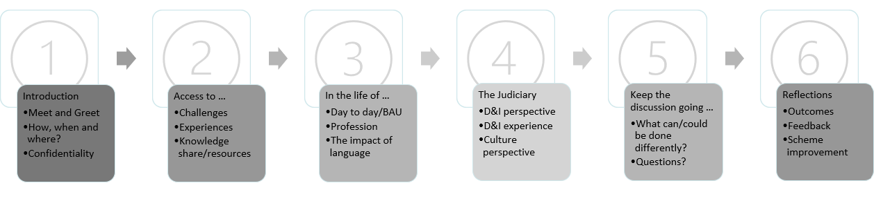
However, this is not exhaustive, and the Judge and the Reverse Mentor can enhance this with their own topics if they find this helpful. A list of possible resources compiled in conjunction with Professor Thomas KC and Kate Brunner KC will be provided. The Mentors may choose to set some preparatory work for the Judges to be completed before the meeting.
What will be expected from you:
- To work with the judges to share your experiences and perceptions honestly and openly.
- To be conscientious in your approach to the arrangement (e.g. to keep to agreed meeting times)
- To treat anything discussed in complete confidence.
- To aim to increase the judge’s understanding of the experience of underrepresented group(s) in the legal professions.
- To be open minded about what you can learn from the experience.
- To engage with reflection at the end of the process.
What support will be available to you:
We have a series of Mentor Support Sessions which will be scheduled on offer to the Mentors on the scheme. These sessions are facilitated by the Leads who you will be introduced to at the Launch Event. They are a safe space and forum in which you can come together and share, question and gain support from the Lead, Judicial Leadership Team, and fellow Mentors. In turn you can use it as a platform to get advice, guidance, and information to support your Judicial Reverse Mentoring journey.
If during the period of your reverse mentoring, you have any queries or issues please contact JudicialLeadership@judiciary.uk

The Judicial Reverse Mentoring Scheme: Pen Portrait
Please complete the information below to provide information which will be used to match you with a mentee. In order that the pairing can be done expeditiously please return this Pen Portrait as soon as possible & at the latest by 4pm on Monday 27th February 2023.
Name xxxxxxxxxxxx
Current role & relevant previous experience
Contact details (email preferably)
Please explain here why you are interested becoming a Mentor?

We will match you with a mentor from a pool of Circuit Judges. Are there any considerations you would like us to bear in mind about how you are matched?

Are there any courts that you appear at regularly? We will try to avoid pairing you with a judge from those courts, but this cannot be guaranteed.

Once complete, please email this form to JudicialLeadership@judiciary.uk

Your personal details will be treated in the strictest confidence, however, to aid the matching process please note that information supplied throughout this form will be shared with your potential Peer Mentee.
DATA PRIVICY
The personal information you provide will be used to match you with a Reverse Mentee. It will be kept on a secure network and will only be accessed by the Leadership Development and Talent Team within the Judicial Office. Information provided will be retained for twelve months after the end of your mentoring, so that the scheme can be evaluated. If you no longer wish to be available to the scheme your personal data will be deleted. You can find more information about how judicial HR processes personal data here:
Judicial Intranet | Data Privacy Notices (judiciary.uk).
PEER MENTOR DECLARATION
If matched:
I confirm my willingness to retain all information disclosed to me during any Mentoring discussion confidentially safe in the exceptional circumstances described in the Guidance.

